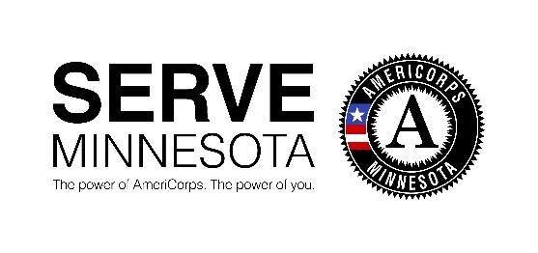

Test Administrator

Preschool Math Project

Organization
ORGANIZATION SUMMARY:
Founded in 1994, ServeMinnesota began as the Minnesota Commission on National and Community Service. It was housed within the Department of Family and Children’s Services and was the designated recipient and administrator of funding for Minnesota's AmeriCorps program. In 2002, the Minnesota Legislature approved the organization becoming a 501(c) (3) non-profit organization with the broader mission of advancing national service and volunteerism across the state.
Mission:
ServeMinnesota is a catalyst to address critical needs in Minnesota by working with AmeriCorps and community partners. We share our proven practices nationally.
We get measurable results through:
- Innovation: researching and applying the best methods to create powerful local solutions
- Investment: raising and allocating funds for AmeriCorps program development, and people serving in those programs, to maximize return
- Alignment: aligning with local community and government priorities and setting consistent program standards to ensure measurable results

Position Description
Job Title: Part-Time Test Administrator
Reports to: Project Manager (Preschool Math Project)
Exempt Status: Part-Time, Temporary, Non-exempt
Hourly Rate: $15.00/hour
Test administrators will participate in training to ensure fidelity of administration of the assessment, conduct the assessment with preschool students over three 3-week assessment windows at assigned site and classrooms, and are responsible for entering assessment data into a data management system and maintaining data confidentiality of students. Hours vary depending on the number of assigned schools. Test Administrators must be available during the three 3-week assessment windows: September 30-October 18, 2019, January 20-February 7, 2020, and May 11-May 29, 2020. Preferred location in the Twin Cities metro, west-central Minnesota, northeast Minnesota, and southern Minnesota.
Employment is contingent on eligibility determined by the results of a criminal history background check.

Essential Job Functions
- Successfully participate in training to ensure fidelity of administration of the assessment
- Conduct assessments with preschool students in accordance with training and required standards over three 3-week assessment windows at assigned site and classrooms
- Faithfully enter assessment data into a data management system, maintaining data confidentiality of students as trained and required.
- Excellent attendance at assigned locations as scheduled.

Qualifications:
Minimum:
- Strong computer skills, including MS Office, internet, and databases
- Experience working with children.
- Knowledge and experience working with individuals, both students and educators, with different backgrounds, resulting in professional behaviors that respect different experiences, cultures, norms, languages, and socio-economic background.
Preferred:
- Experience in conducting educational assessments with fidelity.
- Knowledge of FERPA and maintaining student data confidentiality.

Physical Requirements
ServeMinnesota is committed to compliance with the Minnesota Human Rights Act and the Americans with Disabilities Act and will make reasonable accommodations as possible to enable employees to perform the essential function of their positions. This position requires the ability to:
- Communicate effectively with people and groups in multiple settings within and outside of ServeMinnesota.
- Effectively utilize existing and emerging technology to achieve required results.
- Travel to assigned schools as needed.
Interested applicants are encouraged to submit a cover letter and resume to lisacarlson@serveminnesota.org.
This position is available to all, without regard to Race, color, creed, religion, national origin, sex, marital status, status with regard to public assistance, familial status, disability, sexual orientation, or age. It is also unlawful to retaliate against any person who files a complaint about discrimination. In addition to filing a complaint with local and state agencies that are responsible for resolving discrimination complaints, you may bring a complaint to the attention of the Corporation for National and Community Service.

