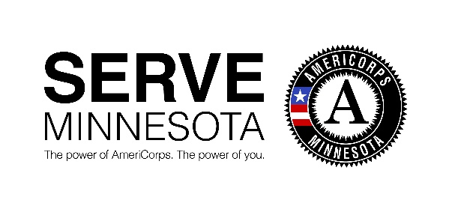
2020-2021 AmeriCorps State Funding
Concept Paper

**Final concept paper must not exceed specified word counts and page limits**
Email completed concept paper and logic model to grants@serveminnesota.org.

Fiscal Host Name: | Program Name:
Address:
City: | State: | Zip Code:

Contact Person
Name: | Title:
Phone: | Email:

Target population of service recipients Geographic area of program

Type of AmeriCorps Program Number of MSYs (member service years/full-time equivalent)
MSYs:

Number of members (please indicate FT, HT, etc.)

- Describe the community problem you are seeking to solve, demonstrating the severity of its impact and defining the affected populations. [200 words]

- Describe your proposed intervention, including the role of AmeriCorps members. [200 words]

- Describe why the proposed intervention is likely to lead to the outcomes identified in your logic model [200 words]

- Describe how the activities of the AmeriCorps members engaged in your solution are evidence-based (e.g. based on research or backed by statistically significant evaluation findings) or evidence-informed (e.g. based on internal performance data, theory of change based on research). [200 words]

- Describe how you will recruit AmeriCorps members from the geographic or demographic communities in which the program would operate. [200 words]

- Describe your organization’s monitoring and oversight plan to prevent and detect non-compliance and enforce compliance with AmeriCorps rules and regulations include those around prohibited and unallowable activities. [350 words]

- Describe how your organization will meet the required financial match associated with the federal AmeriCorps funds. [200 words]

- Please complete the logic model template, detailing how your program inputs and activities are related to your overall goals, and how these result in outputs (countable items, e.g. persons served) and changes in outcomes (impacts measured over the short-, intermediate- and long-term). [See Logic Model Template]

