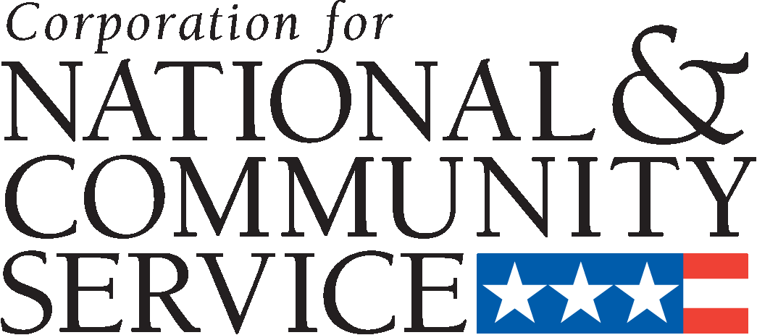
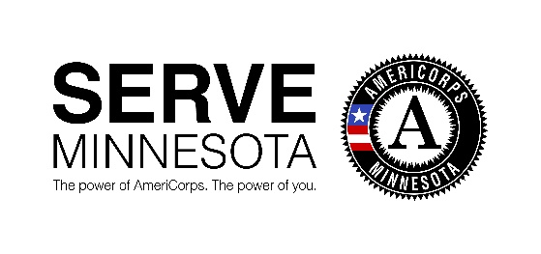

Letter of Intent to Apply for AmeriCorps State Competitive Grant Funding through ServeMinnesota

By completing the below form, you are indicating your intent to submit an AmeriCorps State competitive grant proposal through the federal eGrants system to ServeMinnesota for 2021. This is for recompeting applicants only.

Fiscal Host (Organization):
Name of Program:
Contact Name and Title:
Address:
Phone Number:
Email:
Geographic Service Area:
Approximate request dollar amount:
Number of Member Service Years (MSY) Requesting*:
Number of Members (slots – all types combined):
Type of AmeriCorps Program you want to plan for:

* One full-time member equals one MSY.

Please email your completed form to grants@serveminnesota.org by October 16, 2020 (5:00pm). Thank you for your interest and we look forward to reading your AmeriCorps State competitive grant proposal!

