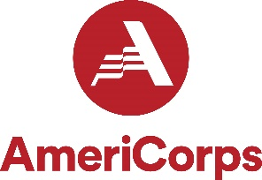
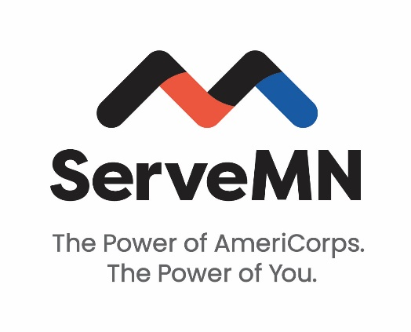

2024-2025 AmeriCorps State Funding Concept Paper

**Final concept paper must not exceed specified word counts**
Email completed concept paper and logic model to grants@serveminnesota.org.

Organization Name: | Program Name:

Contact Person
Name: | Title:
Phone: | Email:

Target population of service recipients Geographic area of program

Type of AmeriCorps Program Number of MSYs (member service years/full-time equivalent)
MSYs:

Number of members (please indicate FT, HT, etc.)

- Summarize the community need you are seeking to positively impact, including the severity and prevalence of the problem. [250 words]

- Describe the core activities that define the intervention/program model that AmeriCorps members will implement or deliver. [250 words]

- Describe why the proposed intervention is likely to lead to the outcomes identified in your logic model. [250 words]

- Describe how the activities of the AmeriCorps members engaged in your solution are evidence-based (e.g. based on research or backed by statistically significant evaluation findings) or evidence-informed (e.g. based on internal performance data, theory of change based on research). [250 words]

- Describe how you will recruit AmeriCorps members from the geographic or demographic communities in which the program would operate. [250 words]

- Describe your organization’s staff structure that will be implementing, providing oversight and monitoring the program. [250 words]

- Describe your organization’s commitment to advance diversity, equity, and inclusion. [250 words]

- Describe how your organization will meet the required financial match associated with the federal AmeriCorps funds. [250 words]

- Please complete the logic model template, detailing how your program inputs and activities are related to your overall goals, and how these result in outputs (countable items, e.g. persons served) and changes in outcomes (impacts measured over the short-, intermediate- and long-term). [See Logic Model Template]

