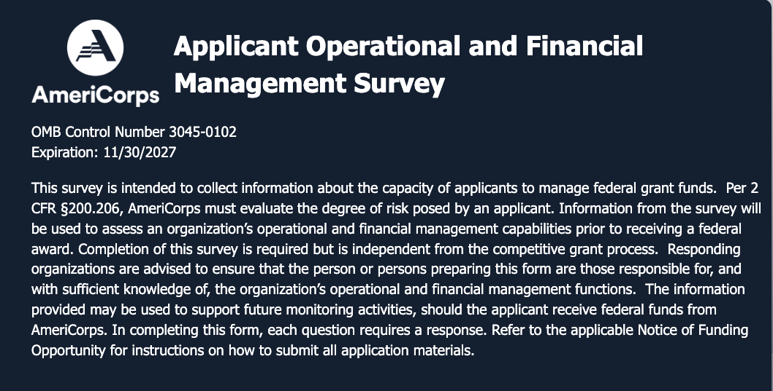
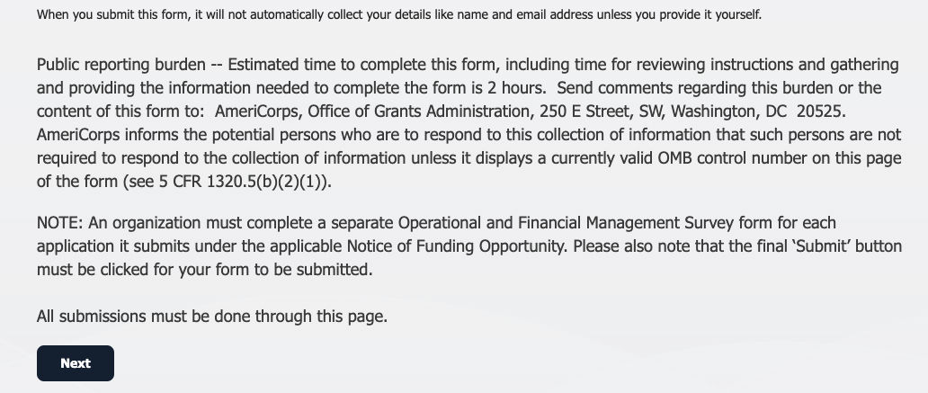

General Information
- Organization Legal Name (As it appears in eGrants)
- EIN
- City, State Associated with EIN
- UEI (Unique Entity Identifier)
- Assistance Listing Number Associated with Funding Opportunity | 94.006
- Application Identification Number (As it appears in eGrants)
- NOFO/Grant Competition | AC State and National
Operational Management
The policies identified below address some of the most critical elements for administration of a federal grant. As a recipient of federal funds, organizations are required to have a full complement of programmatic, financial, and administrative policies, as well as internal controls in place, as applicable. Policies and procedures should be reviewed and refined, as applicable, at least once every two years. Should the applicant receive federal funding from CNCS, full copies of the policies and procedures may be requested for monitoring purposes.

Please indicate whether the organization has current written policies and procedures in the following areas (select Yes or No):
- Personnel/Employee Handbook | Choose an item.
- Financial/Internal Controls | Choose an item.
- Sub-award and/or Service Site Monitoring and Oversight | Choose an item.
- Timekeeping | Choose an item.
- Travel Guidance, including purchase/travel credit card use | Choose an item.
- Procurement | Choose an item.
- Standards for Use of Federal Funds | Choose an item.
- Code(s) of Conduct/Ethics, applicable to employment/purchasing | Choose an item.
- Document Retention | Choose an item.
Please indicate the training areas below that are provided to employees by the organization (select Yes or No)
- Personnel/HR Issues | Choose an item.
- Financial Accounting | Choose an item.
- Risk Management | Choose an item.
- Cyber-security | Choose an item.
- Fraud, Waste, and Abuse | Choose an item.
Financial Management
- Are financial reports (profit and loss, budget vs. actual, etc.) provided to and reviewed by leadership level staff, at least quarterly? | Choose an item.
- Does the organization utilize an automated accounting system? | Choose an item.
- Can the organization’s accounting system separate the receipts and payments of a federal grant from the receipts and payments of the organization’s other activities supported by separate funding streams? | Choose an item.
- Can the organization’s accounting system summarize expenditures from a federal grant according to different budget categories such as salaries, rent, supplies, and equipment? | Choose an item.
- How often does the organization post transactions to the accounting system ledger(s)? | Choose an item.
From 26, if other selected, please describe:
- Does the organization use an automated payroll system? | Choose an item.
Please indicate whether organizational leadership approval is required for any of the following financial transactions (select Yes or No):
- Opening/Closing Bank Accounts | Choose an item.
- Opening Lines of Credit | Choose an item.
- Assigning Credit Cards | Choose an item.
- Buying/Selling Property | Choose an item.
- Financial Investment/Divestment | Choose an item.
- Has the organization issued loans to an employee or officer of the organization or forgiven/written-off any loans or debts in the last year? | Choose an item.
- Please identify who is authorized to write-off any debt owed to the organization as a bad debt. | Choose an item.
- Has the organization experienced cash flow deficits at any point in the previous 2 years? | Choose an item.
Compliance
- Has the organization received federal funds for similar programs or projects? | Choose an item.
- If yes, has your organization met federal program requirements for similar programs? | Choose an item.
- Has an audit been performed on the organization’s financial accounts? | Choose an item.
- If yes, what was the audit opinion? | Choose an item.
- If applicable, has the organization addressed any outstanding deficiencies identified in the most recent audit? | Choose an item.
Please provide any clarifications or similar remarks/information in the section below (optional):
Preparer’s Certification
Preparer’s Name (First, Last)
Preparer’s Email
Preparer’s Position Title
I certify that the above information is complete and correct to the best of my knowledge and ability. | Choose an item.
Date of Certification

This form must be saved and submitted as a Word document, do not save as a PDF.

Privacy Statement -- In compliance with the Privacy Act of 1974, the following information is provided: The collection of this information is authorized by the provisions of the National and Community Service Act of 1990, by the National and Community Service Trust Act of 1993, and the Serve America Act of 2009. The primary purpose of the information is to determine if appropriate systems are in place to manage federal grant funds or, if not, to identify training and technical assistance a grantee may need to develop or enhance appropriate systems. Completion of this survey is required as an element of CNCS’ pre-award risk assessment process. The information provided will be maintained and treated confidentially. However, appropriate federal, state, and local law enforcement entities may request and obtain this information under certain circumstances. Otherwise, the information provided will not be disclosed without express written permission.

